Cache Aside Strategy

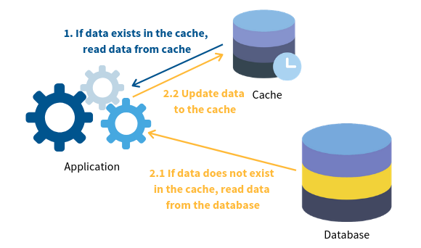

Read Through Strategy

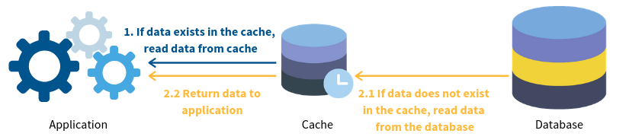

Write Through Strategy



Write Back Strategy

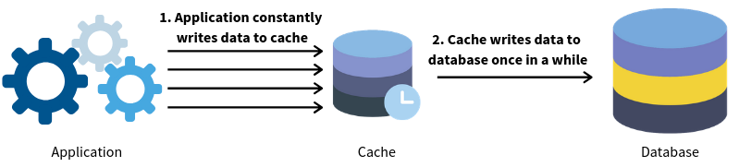

Write Around

